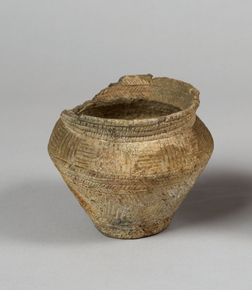
Incised Groove Vessel

- Angular profile
- Decorated entirely with incised grooving.
- Herring-bone motif rings the internal rim
- The external decoration is zoned. There is a vertical ladder pattern on the rim/ neck, a band of alternate vertical and horizontal panels on the shoulder with a herring-bone design beneath, and the lower body has infilled chevron patterning with a herring-bone motif on the lower section.
- There is a circular hole in the base.
- Found in Mitchelstown, Co. Cork.

Shields
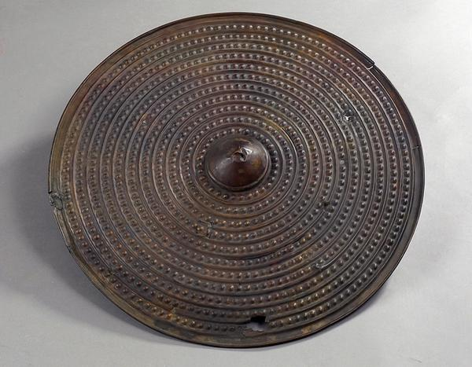
- Shields were essential bronze age weapons.
- 99% of shields created during this time would have been made from wood or leather, only few survived and were found mainly in Irish peat bogs.

- Bronze shields were made by beating bronze into flat sheets, this technique that wasn't discovered until late bronze age.
- These shields, which have mostly been found in Britain and Ireland, have been dated to the late Bronze Age (from the period 1200 until 800 B.C.).
- They are described as being the Yetholm type and are named after a site in Scotland where three of them were found.
- Purchased from the Pitt Rivers Museum, in Dorset, England.
- believed to have been found in Ireland,
- Later discovered that the Antrim Shield was not found in County Antrim but was in fact taken from the River Thames at Mosley (between Walton-upon-Thames and Hampton) in England, in September of 1864.
- 66cm in diameter.
- The thickness is 5mm.
- Ornamented with a central umbo/boss around which there are eleven concentric raised ribs and rows of small bosses.
- The design is the result of the repoussé (French meaning ‘to push up’) method by which the metal is shaped by hammering from the reverse side.
- Big umbos originally helped to deflect blows and mount grip in combat, however, in the context of this object, it is believed that these features are simply ornamental.
- It is believed that this particular shield would have been used for ceremonious purposes only and not in combat as one might expect.
- The weakness of the sheet bronze can be illustrated in the fact that it was damaged in several places by the boatman who took it out from the River Thames with his boathook.

- A very similar shield was found in Lough Gur, Co. Limerick.
- It is believed that it had been deposited as an offering in the lake there which in the 1840s was then drained.

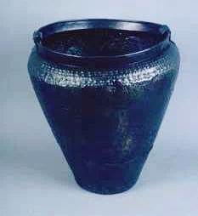
Cape Castle Bucket:
- Found in the Cape Castle bog near Armoy in County Antrim,
- Late Bronze Age bucket,dated to around 700 B.C
- Discovered in 1880.
- It is noteworthy for its decoration above the shoulder which is covered with small, raised bosses.
- Below the shoulder it is decorated with triangles which were produced in the repoussé style.
- The diameter at the shoulder is 400 cm and 359cm at the neck, with the height being 470 cm.
- There have been numerous repairs made on the object and a gap at the base, which has been damaged by corrosion, has been filled with an unknown substance.
- Like the cauldron, this bucket would have been used at feasts.
- Hosting lavish feasts and giving vast quantities of alcoholic drink to followers was an important part of the political career of a prehistoric leader during this period.

Ballyscullion Cauldron

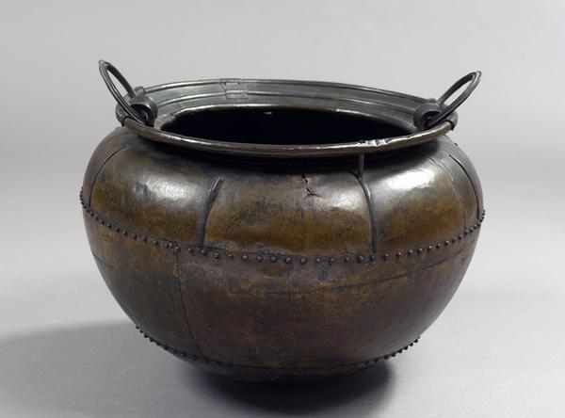
- Unearthed 1880, County Antrim (c.800 BC).
- Dated to the Late Bronze Age.
- Found in the parish of Ballyscullion in County Antrim June,1880.
- Characteristic features seen on the body of the vessel show the level of technical skill achieved at this period,
- In panel beating; body and rim formed from 8 pieces of bronze, each hammered to a thickness of approx. 1 millimetre.
- Riveting; horizontal rows of conical headed rivets, which are both functional and decorative
- Handles; 4 pieces of bronze- circular ring of ribbed cross section; sheet bronze ribbed and flanged U shape tube; 2 sheet bronze half tubes riveted to rim edges.
- 8 vertical bronze stays riveted to the body exterior - all but one broken, suggesting extensive use.
- Ireland was the main area of Cauldron production; all complete ones have been excavated here.
- Cauldrons have a significant role in the context of the large-scale ceremonial feasting seen by the ruling elite as an important mechanism for the maintenance of power and status.
- Meat would be cooked in cauldrons and portions distributed among a chieftain’s

- Cauldrons are also credited in myths and legends both in Ireland and Worldwide, with possessing magical properties. These include the miraculous capacity to hold enough food,( including entire carcasses of animals such as sheep and pigs), to feed an entire company.
- The care with which this Cauldron has been repaired also suggests how prized it was.
- Because so many of them have been discovered in bogs, archaeologists believe that they were of special ritual significance.
- It is not believed that this cauldron was used for cooking, however it may have been used to brew or to serve drinks.

